EN. 605-702

Project 2: RouteMe  
Containerization  
Benjamin Huang

## Business Use Case:

This application stores a list of customers and addresses in a database and allows the user to optimize their route. The user can select which customers they need to visit so that they can be added to their route. The user can edit the route list by clearing the list and re-selecting the customers. With a potential list of customers selected, the user can generate the optimal route which is powered by Google Map API. The user can add more customer addresses through the form at the bottom of the page. The application will use Google Map API to geocode the address into latitude and longitude which is used to generate the optimal route.

Note: The website is live and working as of the writing of this report at: <http://routeme-alb-1630067429.us-east-1.elb.amazonaws.com/> However, it may be taken down because of costs.

# Architecture Diagram

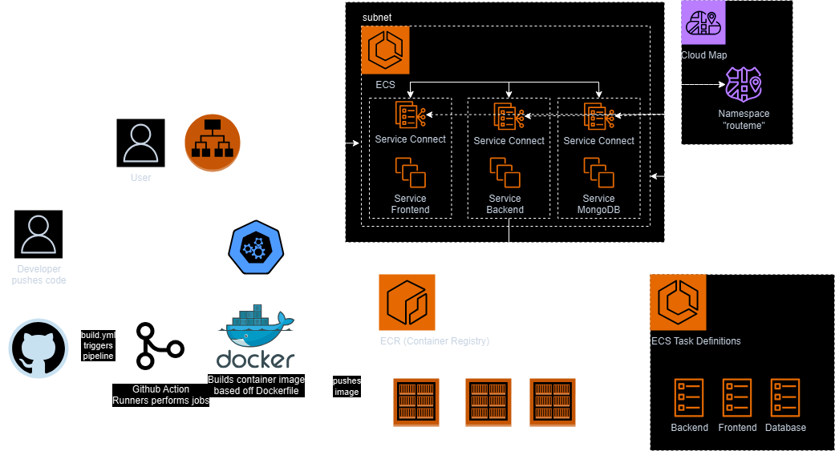

## Tech Stack and Deployed Resources:

The code for this project is deployed to GitHub.

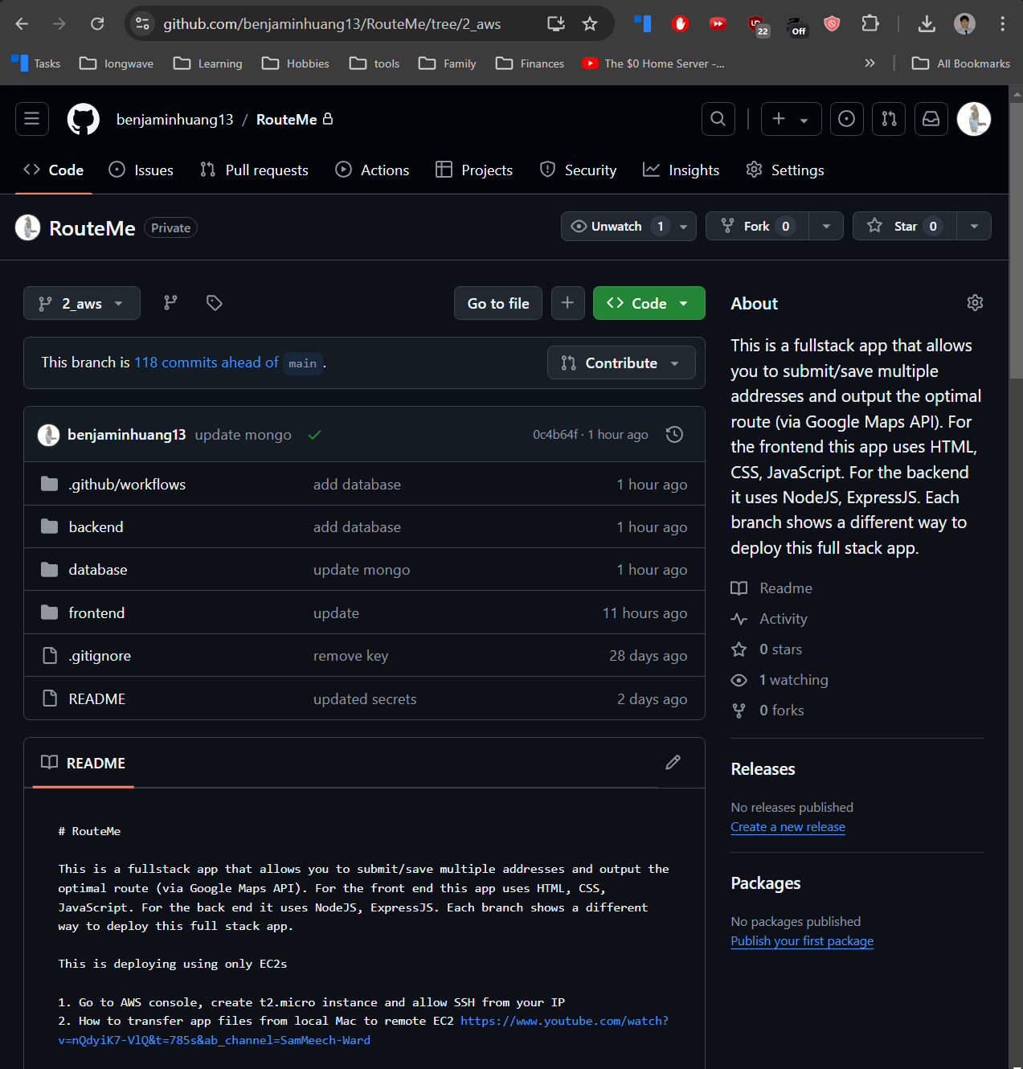

Secrets are stored in GitHub Actions secrets and variables. This allows secure storing and transit of secrets onto the docker images.

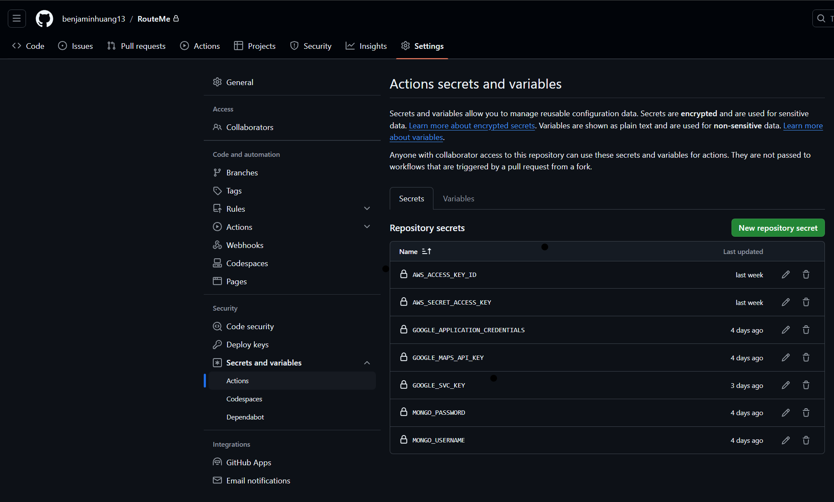

GitHub Actions is used for CI/CD. The build.yml file uses Docker and the Dockerfile to build three images (frontend, backend, database) and is triggered to run every time a push happens.

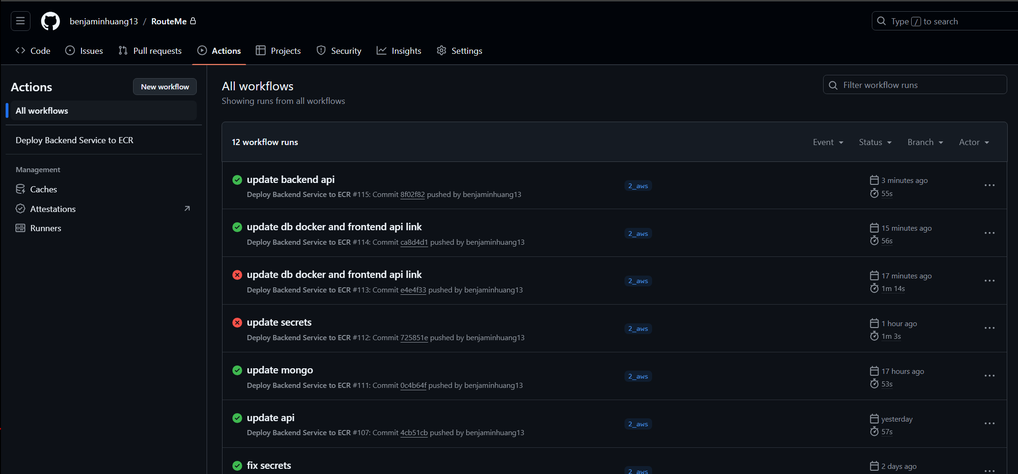

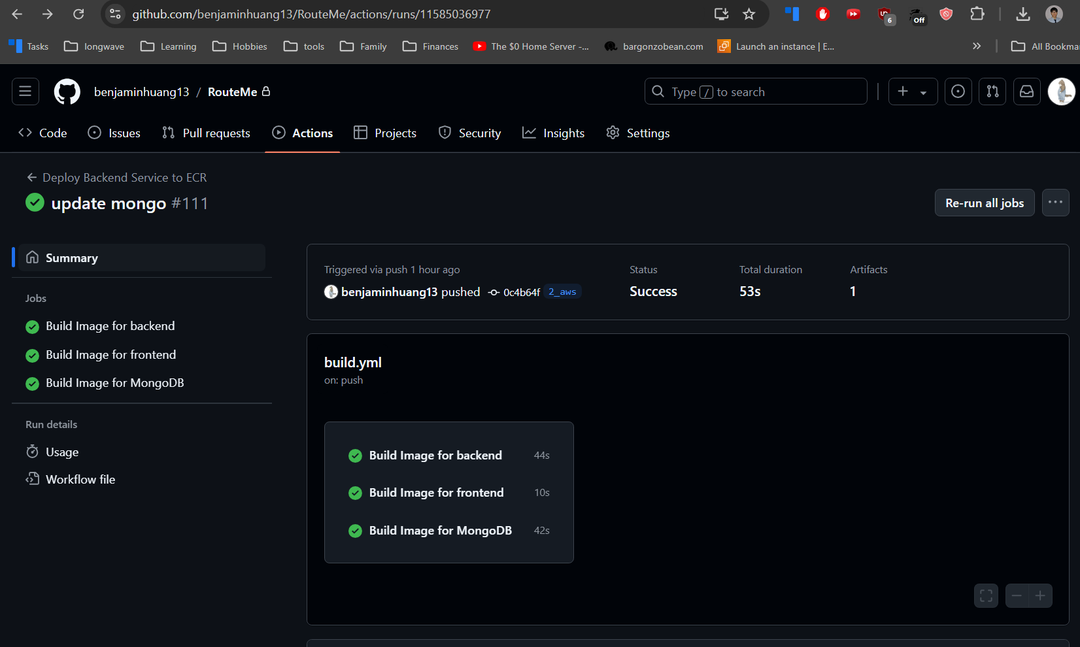

Below is the workflow for the frontend build process. More details can be found in the build.yml file and Dockerfile in /frontend directory.

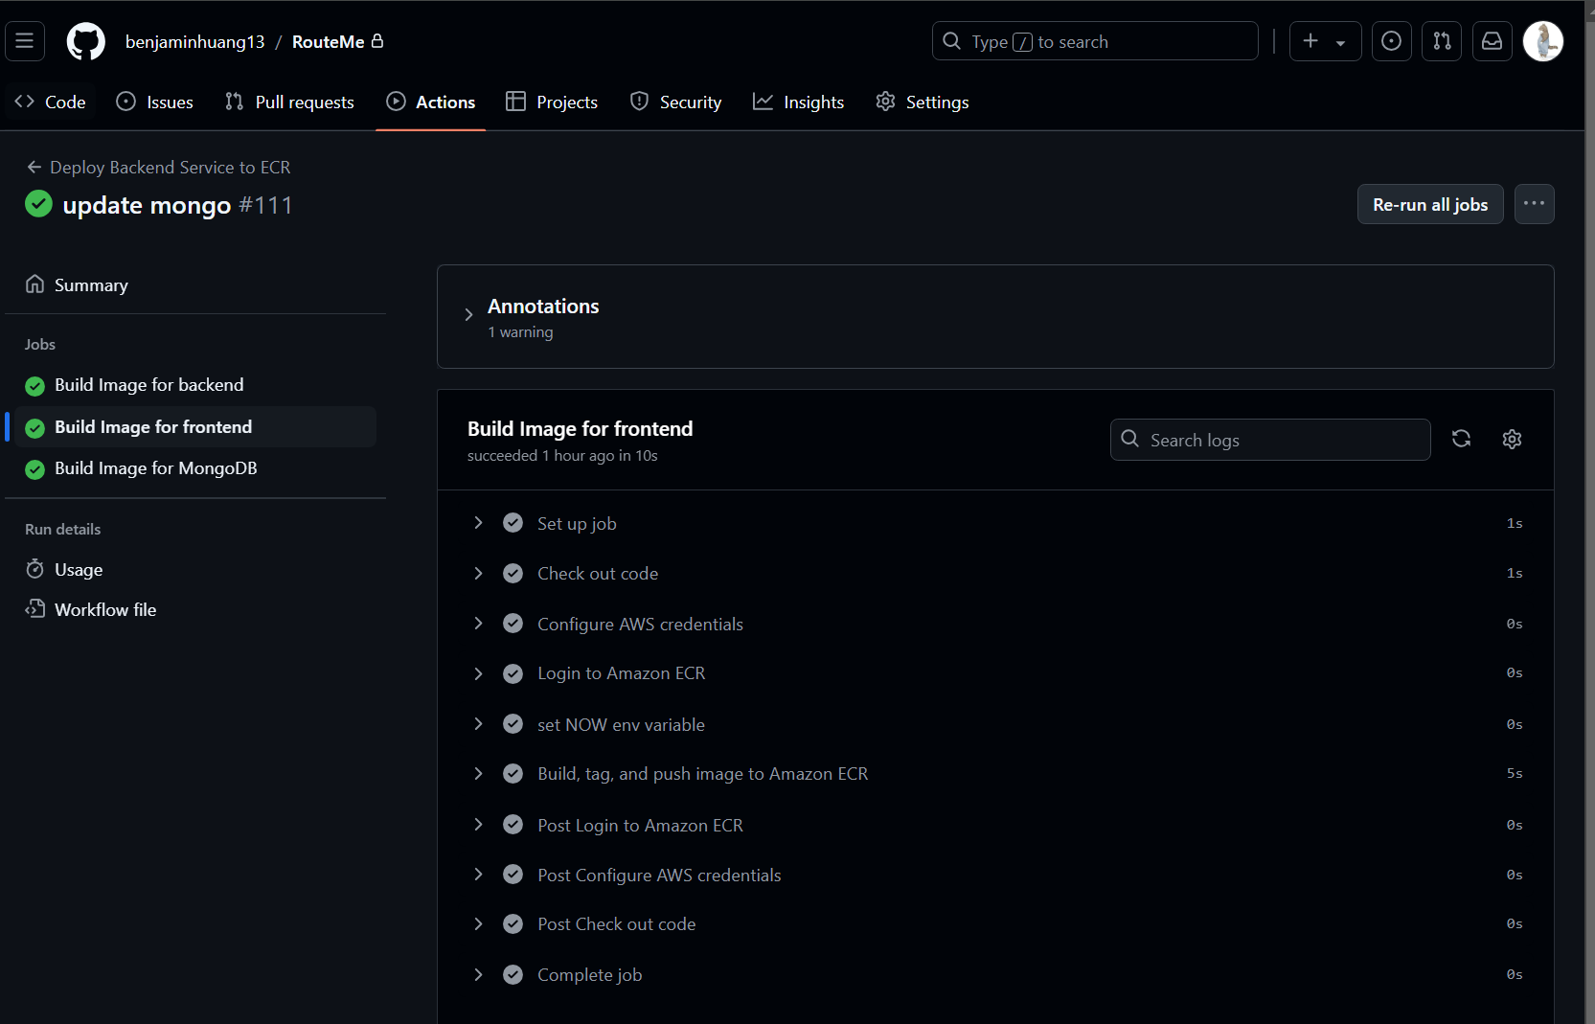

Backend workflow:

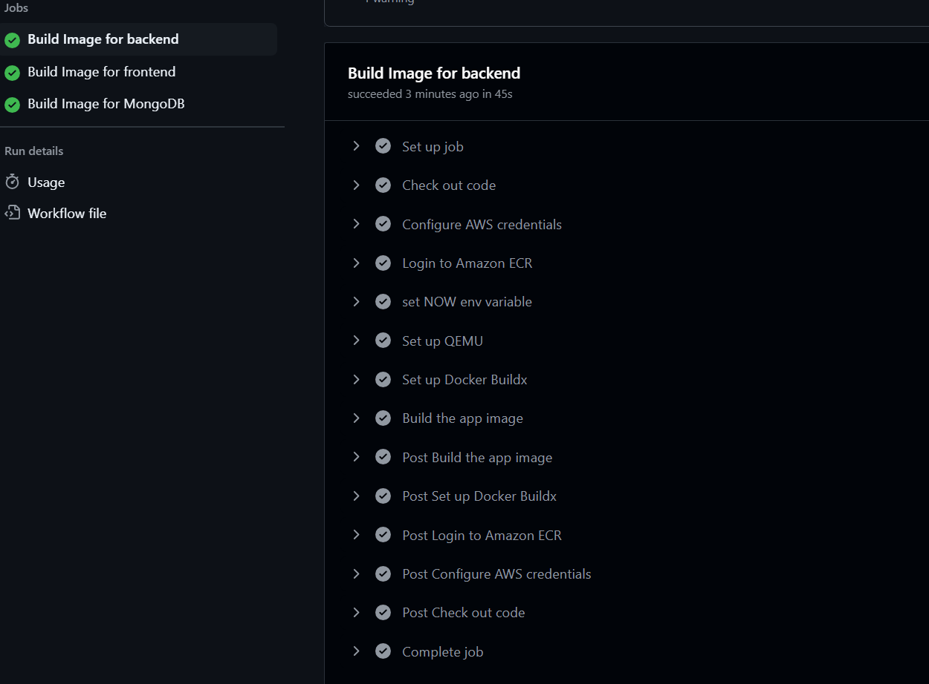

The CI/CD pipeline authenticates into AWS and the three container images are then tagged and uploaded to AWS Elastic Container Registry (ECR).

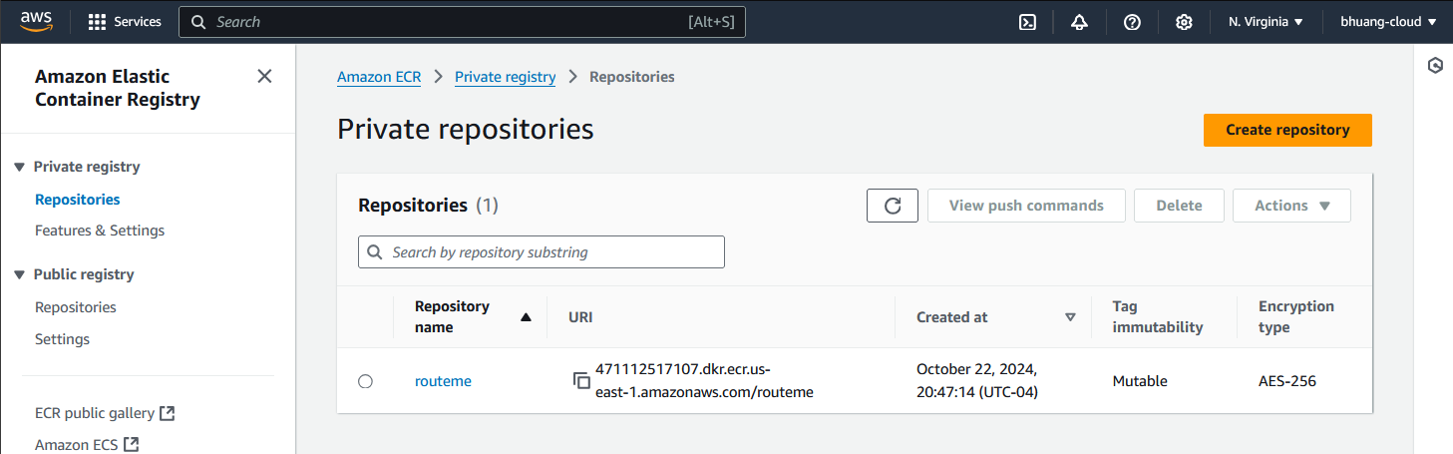The different images can be seen below:  
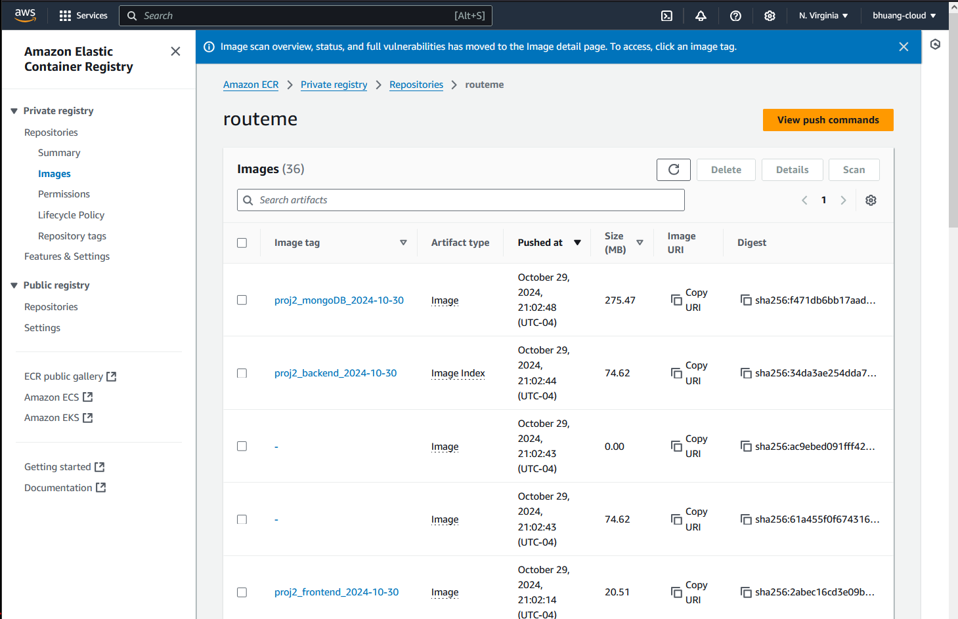

To use the images in ECR for ECS, three ECS Task Definitions are created to outline how to build the ECS services.

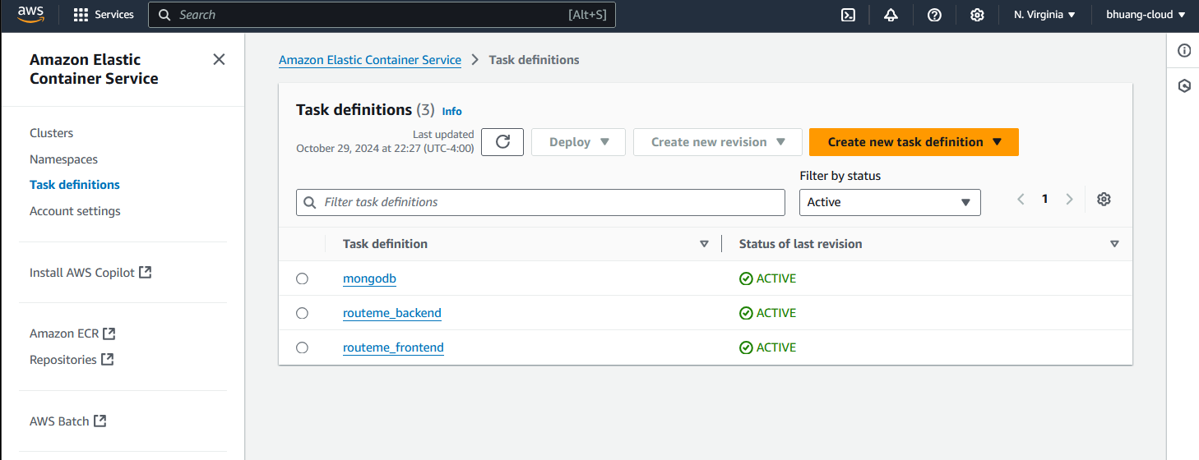

Frontend Task Definition  
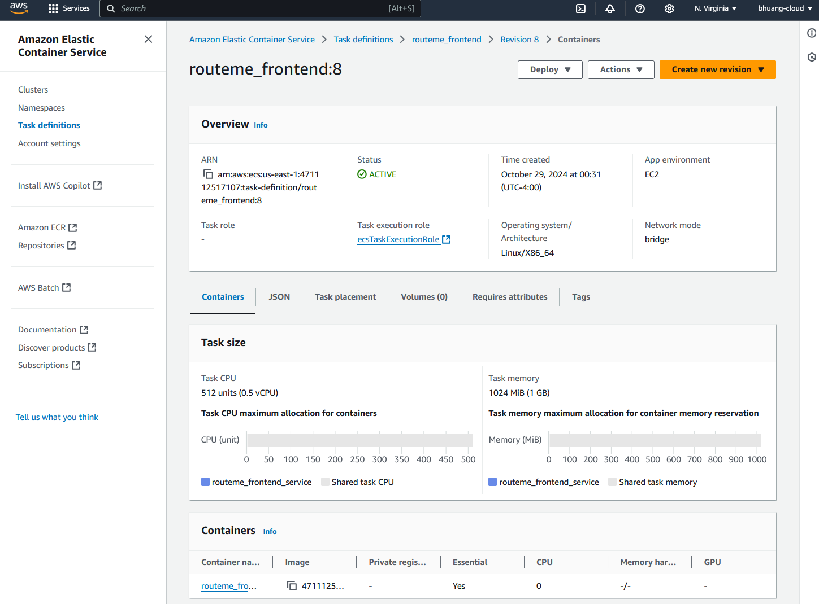

Backend Task defintion  
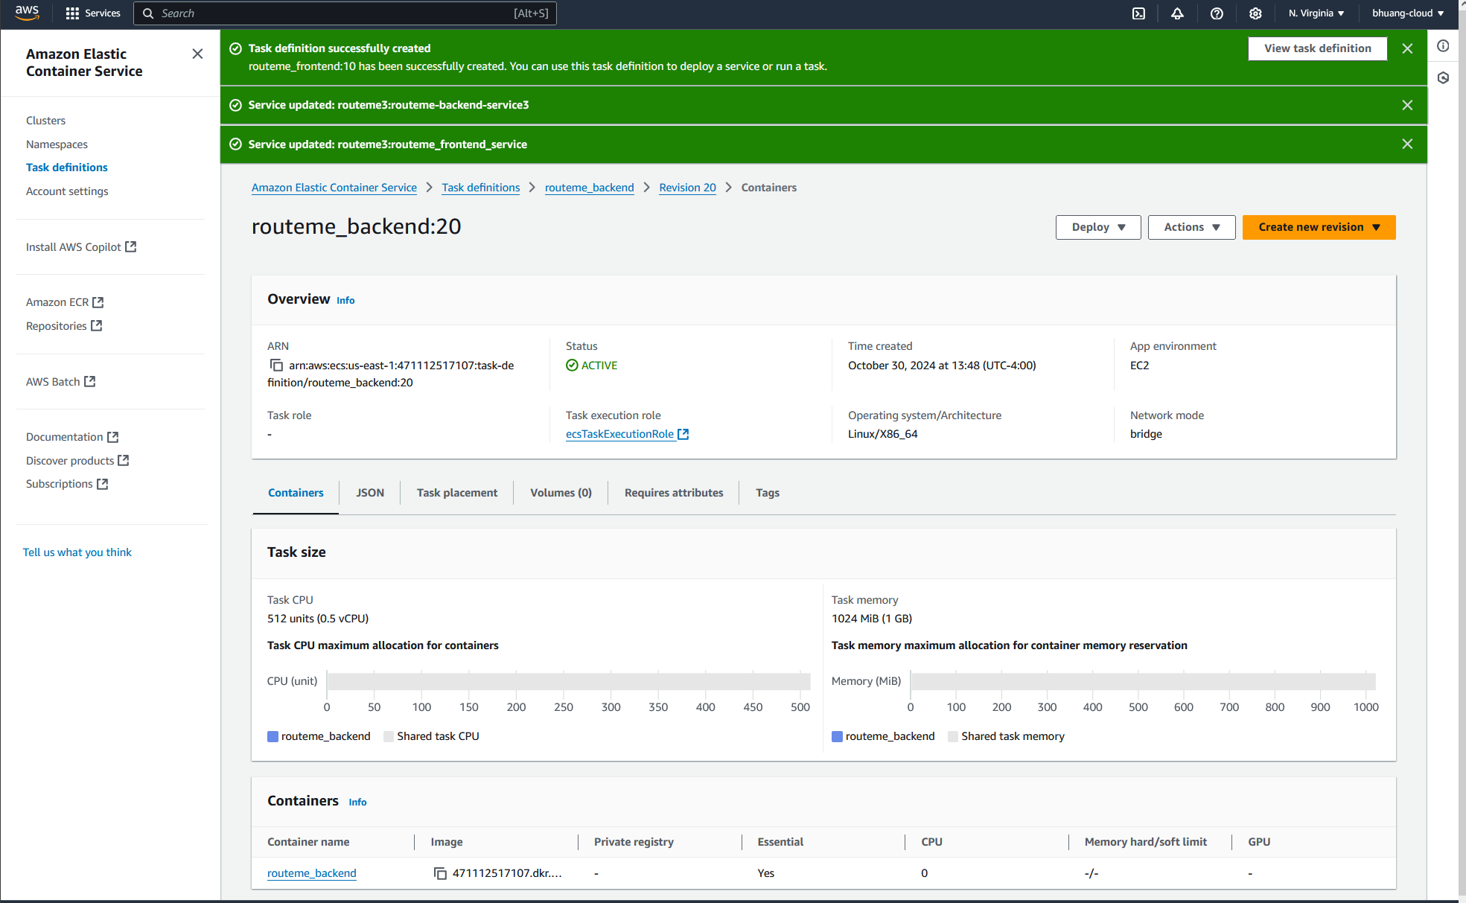

MongoDB Task Definiton  
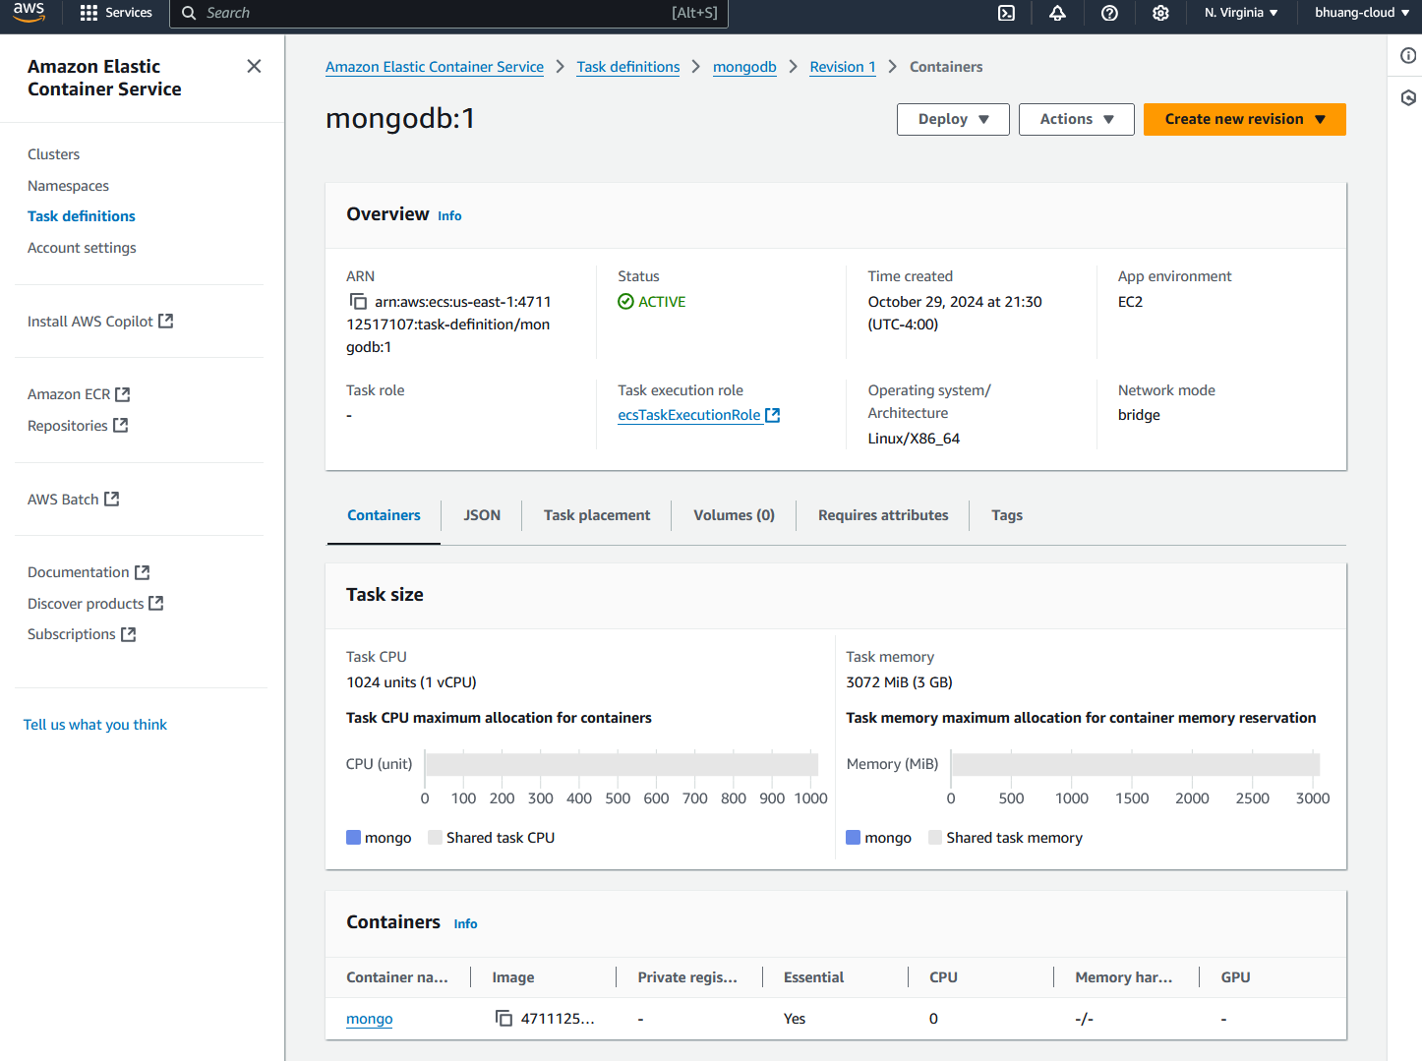

This project is hosted in an ECS Cluster called “routeme3”. Using EC2 deployment and bridge network mode.

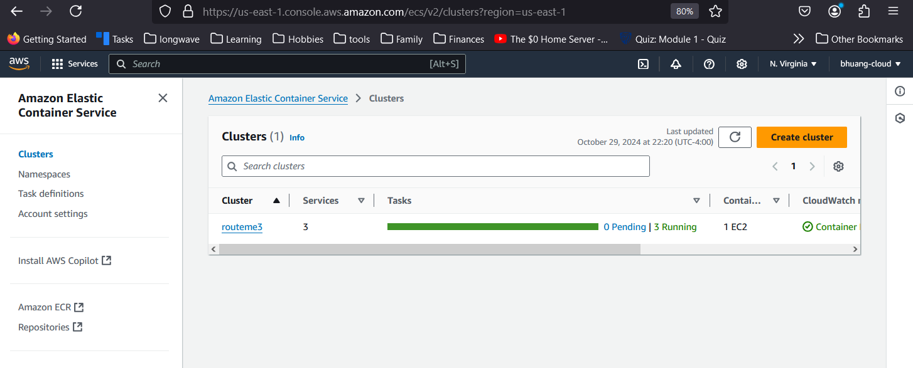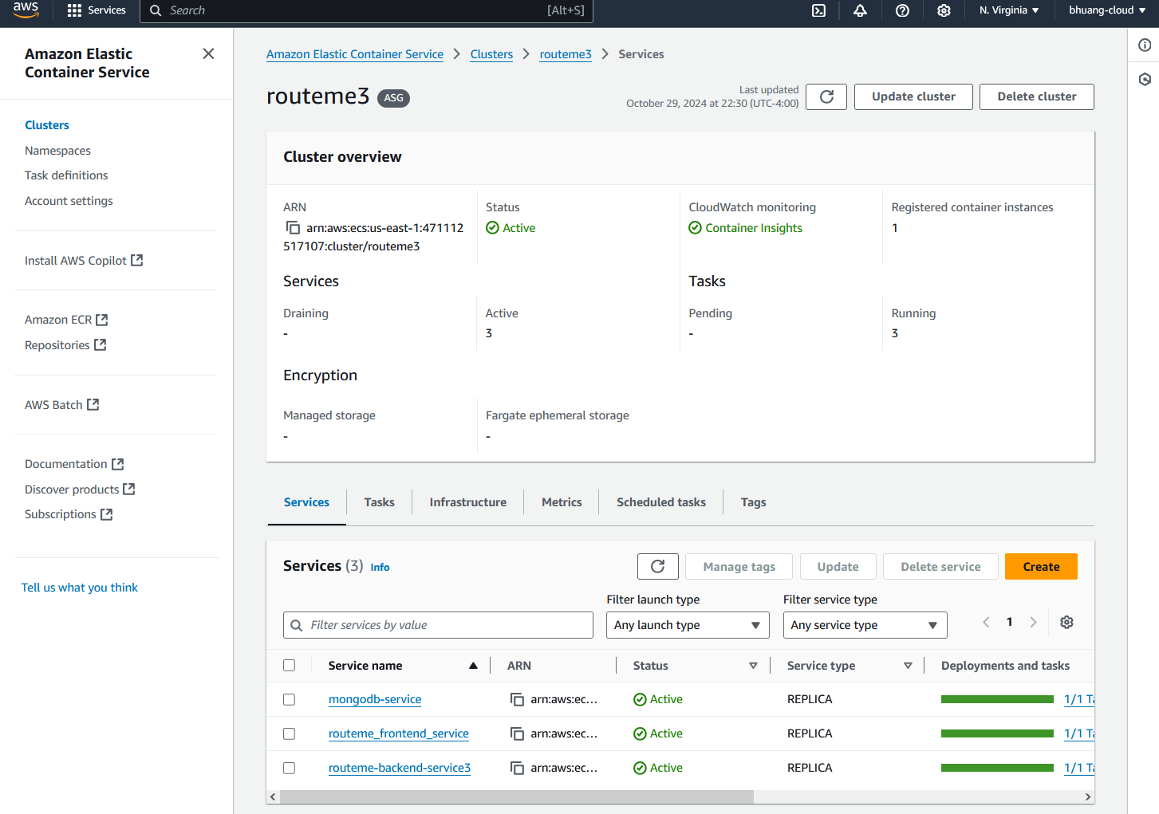

1. The application’s frontend is built using HTML, CSS, JavaScript and is hosted in the ECS cluster as the service “routeme-frontend”.
2. The application’s backend is built using NodeJS and ExpressJS to create a Data Access Object (DOA) API. This is hosted in the ECS cluster as the service “routeme-backend”.
3. The document-based database is hosted in the ECS cluster as the service “mongodb”, and it is used to store customer data. The backend server sends requests to the database to store or retrieve customer data.

These 3 services are created in the ECS, each service can be see below.

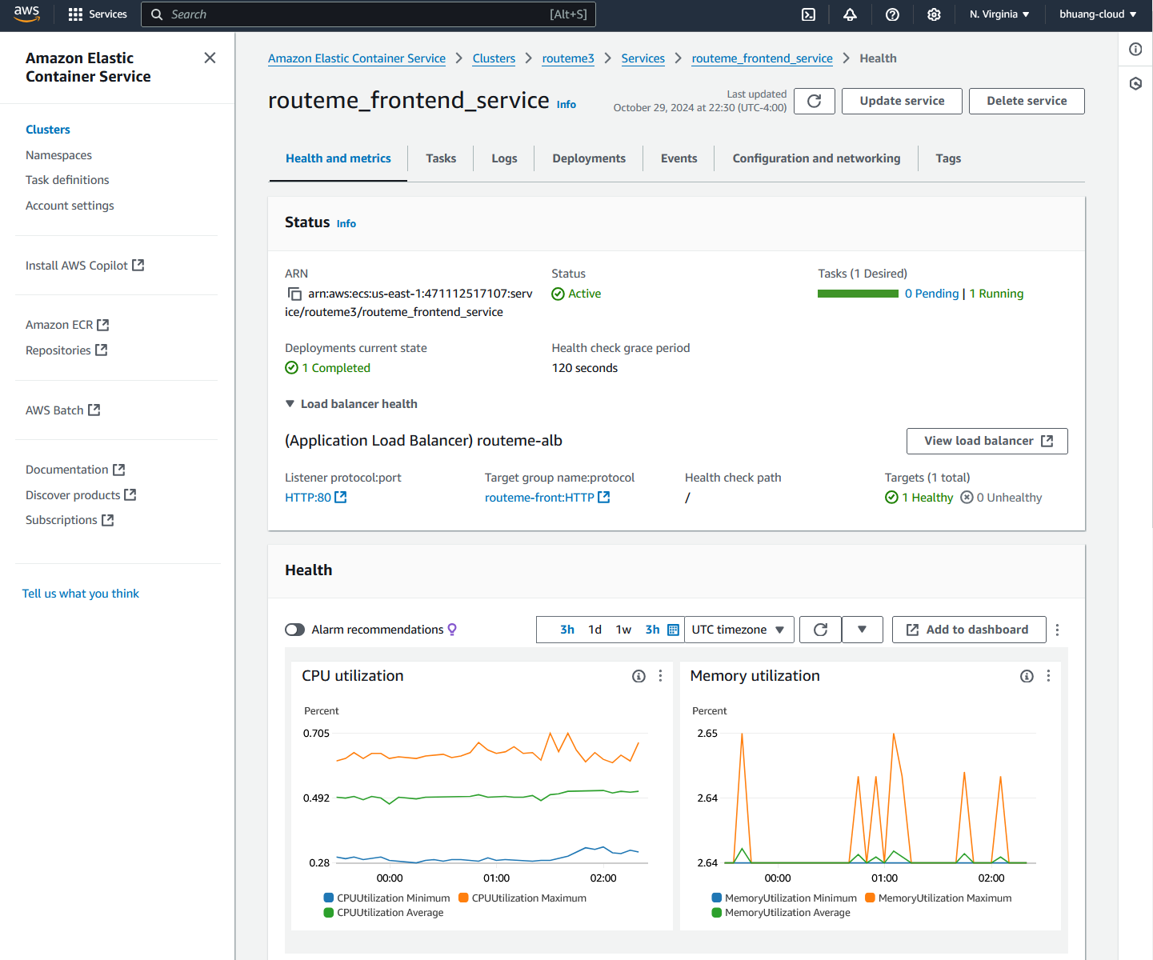

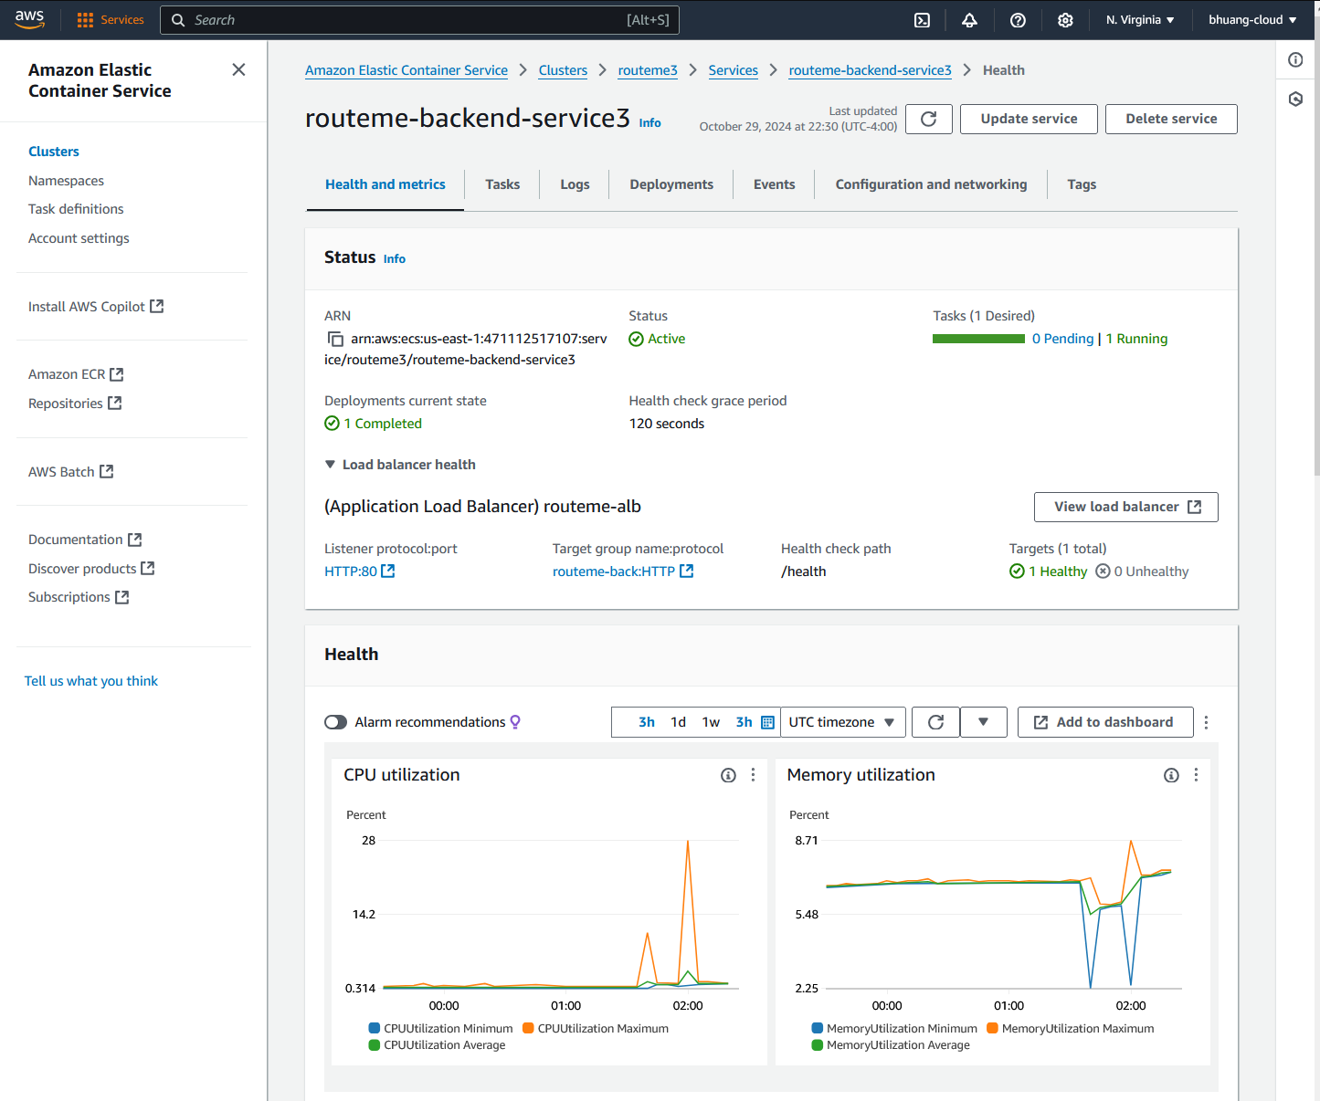

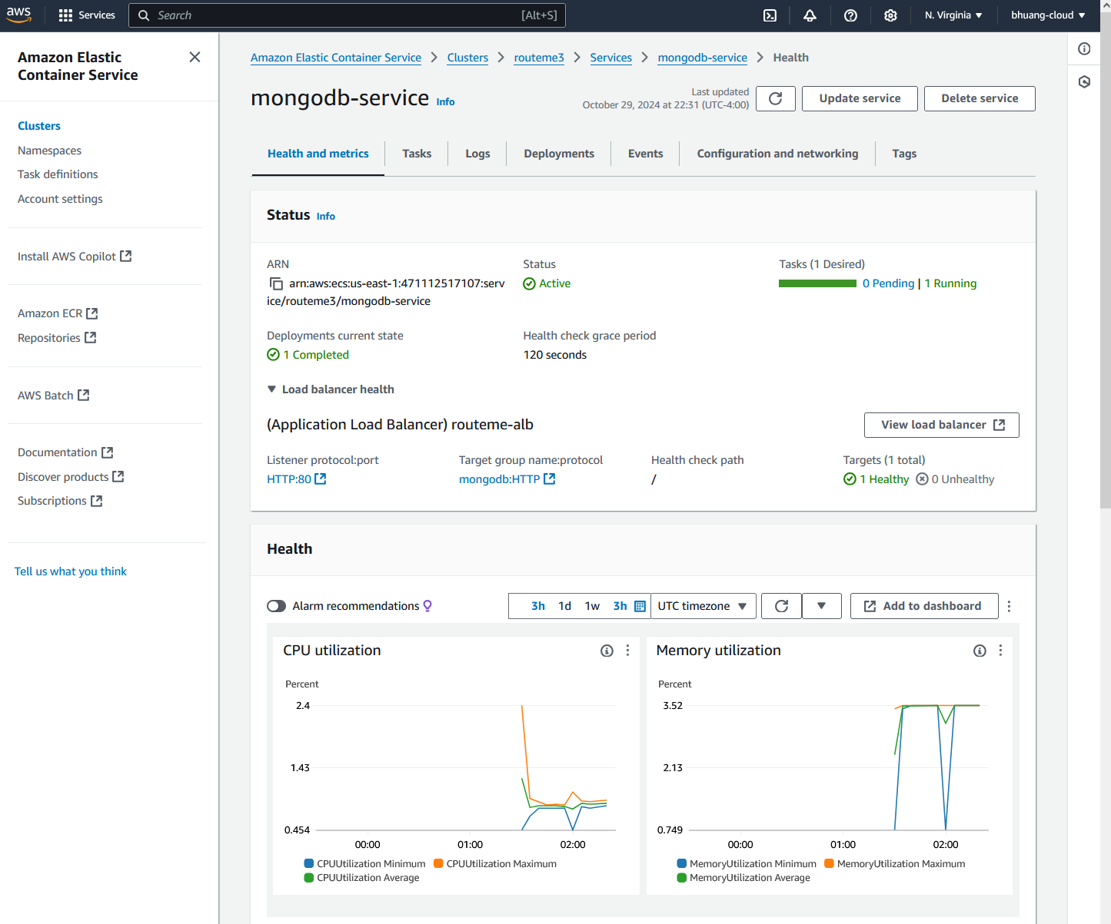

For communication between services, Service Connect is used to connect to the backend services and MongoDB service.

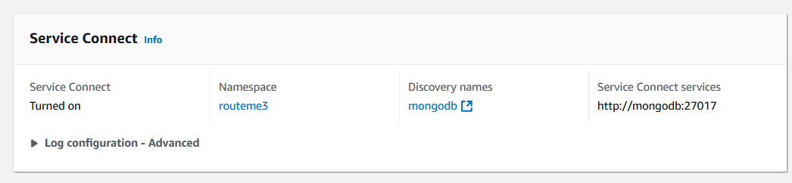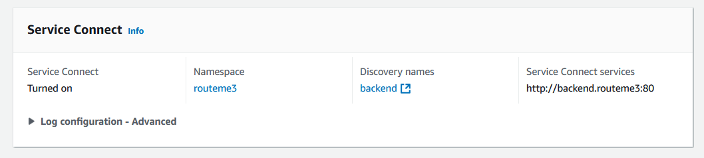Which uses the ”routeme3” Namespaces

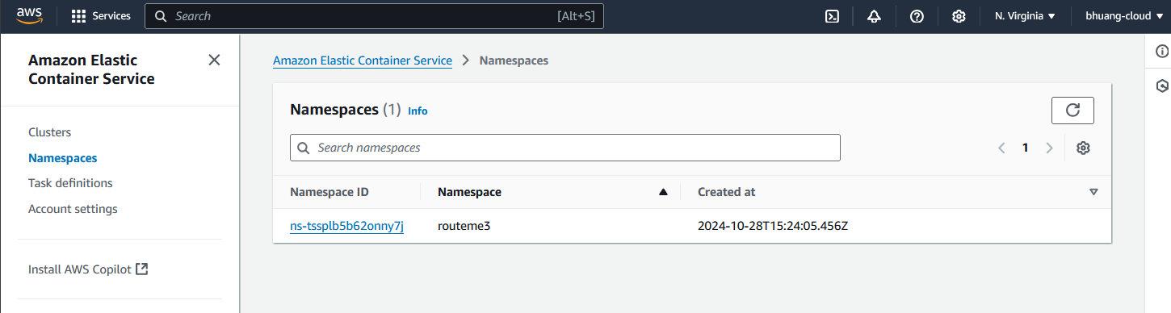

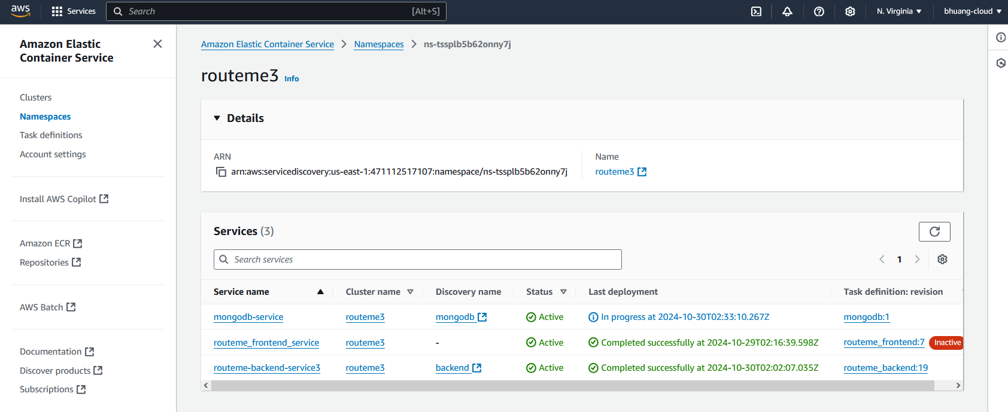

To process some of the google maps functions, Google Map API is used:

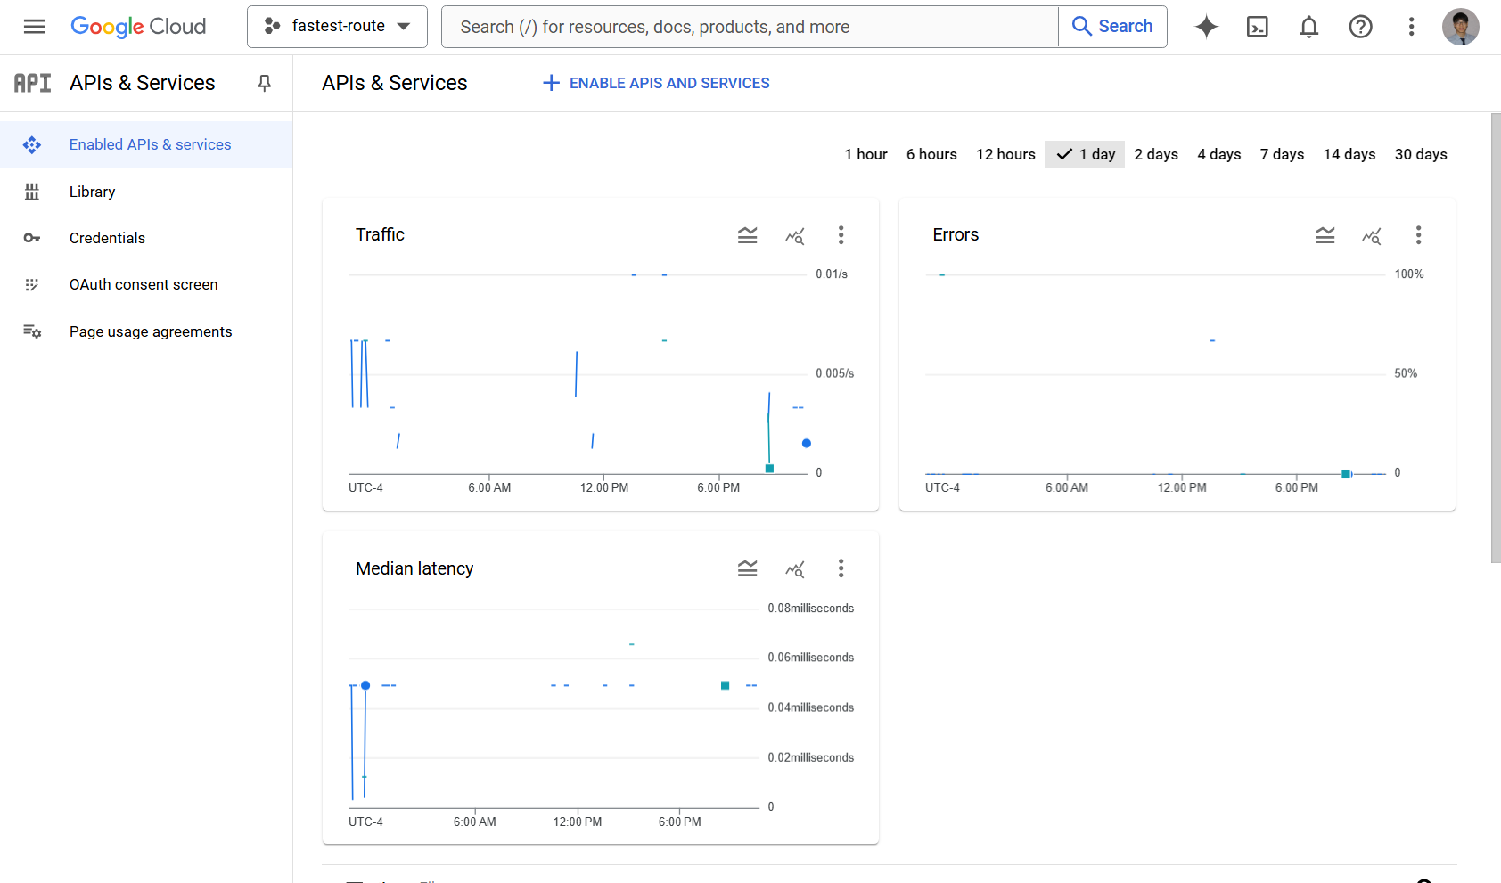

# Demo

Below are gifs of the project demo. Please view in Microsoft Word.



